SCHOLARSHIP
GENERAL EXCELLENCE
APPLICATION FORM 2023

St Thomas’ Primary School is part of a faith community centred on the life of Jesus,
as expressed in our Motto,
‘TOGETHER IN CHRIST’’

Our Vision is to 'educate the whole child' and empower learners as global citizens, to be curious,
collaborative, creative and critical thinkers, inspired by Christ.

Our School Values are visible throughout the school and our students, staff and parents strive to
live these out in their daily lives:
EXCELLENCE
INCLUSIVITY
TRUTH
COMPASSION
COMMUNITY
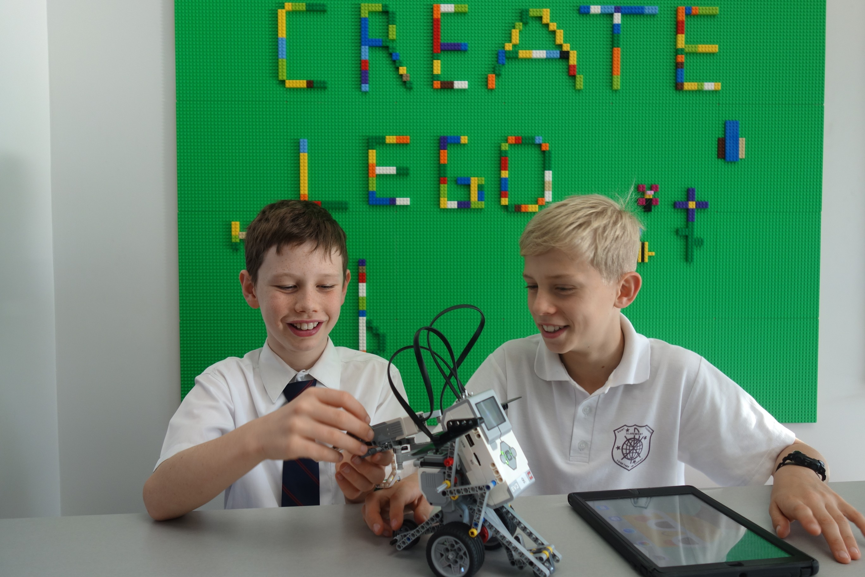

ST THOMAS’ PRIMARY SCHOOL SCHOLARSHIPS 2023 - GENERAL EXCELLENCE

The St Thomas’ Primary School General Excellence Scholarship is now open to new and existing students who would not otherwise be able to attend or continue their child’s education at St Thomas’ for financial reasons (statutory declaration of assets/liability required).
The scholarship will cover either 100% or 50% of tuition fees for your child, and other fees at the discretion of the Principal. Costs not covered by the Scholarship include booklist, uniform, external music tuition, student iPads (for Years 3-6 students), excursions/camps, swimming lessons and P & F levies.
These scholarships are funded by the generosity of the school and broader community and are available for the duration of a child’s education at St Thomas’ Primary School.
We welcome applications for children who reflect our school values and who are eager to fully participate in the school and all the opportunities St Thomas’ Primary School has to offer.

Scholarships will be offered for the start of Term One 2023.

External applicants are required to submit:
- A Scholarship Application Form
- A summary of their child’s achievements outside of the classroom
- If applying for a Year 3 or above entry, a handwritten letter from your child (no more than one page) outlining their interests and why they would like to attend St Thomas’
- Two of your child’s most recent school reports, and
- A St Thomas’ Financial Declaration Form

If your child is already attending St Thomas’ Primary School and you wish them to be considered for the scholarship, please submit:
- A Scholarship Application Form
- If applying for a Year 3 or above entry, a handwritten letter from your child (no more than one page) about their interests and why they want to attend St Thomas’
- A St Thomas’ Primary School Financial Declaration Form
Applicants must be supportive members of the St Thomas’ School Community and be prepared to abide by the Catholic school ethos and policies.

Continuance of a St Thomas’ Primary School General Excellence Scholarship is subject to the recipient’s adherence to the school’s standard enrolment protocols and periodic review by the Principal to ensure the scholarship holder consistently demonstrates exemplary standards of conduct throughout their schooling at St Thomas’ Primary School.

APPLICATION FOR ADMISSION CHECKLIST

To apply for this Scholarship at St Thomas’ Primary School, please ensure that you have completed all sections of the application:
- Certified copy of Full Birth Certificate
- Copy of Baptismal Certificate (If applicable)
- Handwritten note from child (required for students entering Year 3 and above)
- Copy of current Immunisation History Record (available via Medicare)
- Visa Information (if applicable)
- Copy of last two school reports
- A signed statutory financial declaration form

Please note that internal candidates only need to provide a handwritten letter (if child is Year 3 or above).

PROCESS

- St Thomas’ Primary School will confirm in writing receipt of your completed application.
- An interview with the Principal of St Thomas’ Primary School will be arranged for Parents/Guardians and the student for shortlisted applicants.
- Scholarships are awarded at the discretion of the Principal.
- All applicants will receive a letter from the Principal indicating the results of their application.

Applications must be received by 4pm on Tuesday 15 November 2022.

Please note: All scholarship applications will be treated with the utmost confidentiality.

If you are applying for a scholarship for more than one child in your family, please complete a separate form for each child.

CONTACT INFORMATION

Attn: The Principal
Mail: St Thomas’ Primary School,
8 Warden Street, Claremont WA 6010
Phone: 08 9286 9500
Email: admin@stthomas.wa.edu.au
Website: www.stthomas.wa.edu.au/

APPLICATION FORM: GENERAL EXCELLENCE SCHOLARSHIP

STUDENT DETAILS
Surname:
Given Names:
Known as:
Date of Birth: | Gender: Male / Female
Student’s Residential Address:
To Commence Year Level:
Current School: | Current Academic Year:
Previous Schools Attended and Years:

SIBLING DETAILS (please place in order of birth)
Name: | Date of Birth:
Name: | Date of Birth:
Name: | Date of Birth:
Name: | Date of Birth:

MOTHER / GUARDIAN DETAILS
Surname: | First Name:
Address:
Mobile No: | Home No:
Work No: | Email:

FATHER / GUARDIAN DETAILS
Surname: | First Name:
Address:
Mobile No: | Home No:
Work No: | Email:
Please tell us why you would like your child to attend St Thomas’ Primary School:

Please provide a summary of your child’s achievements outside of the classroom.
e.g., achievements, interests, community involvement.

As parents, please provide some examples of how you can contribute to our school community?

Please indicate any financial or other family circumstances deemed relevant:

Do you have any Government concession cards? Yes / No Details: ________________________

By signing this form, I/we understand that all details supplied in this form will be held in the strictest confidence by the Principal. The information contained in this application is true in every particular. All Scholarships are awarded on the basis that our child will maintain high standards of academic endeavour and conduct throughout their enrolment and remain at St Thomas’ Primary until the conclusion of Year Six.

Name of parents/guardians:
Signatures:
Date:

