2023 SCHOLARSHIPS NOW OPEN

ST THOMAS’ PRIMARY SCHOOL
CLAREMONT
Kindergarten to Year 6

‘A small school with big opportunities’

EDUCATING FOR THE FUTURE

https://www.stthomas.wa.edu.au/

St Thomas’ Primary School is part of a faith community centred on the life of Jesus, as expressed in our Motto,

‘TOGETHER IN CHRIST’
Our Vision is to 'educate the whole child' and empower learners as global citizens, to be curious, collaborative, creative and critical thinkers, inspired by Christ.

Our School Values are visible throughout the school and our students, staff and parents strive to live these out in their daily lives:

EXCELLENCE

INCLUSIVITY

TRUTH

COMPASSION

COMMUNITY
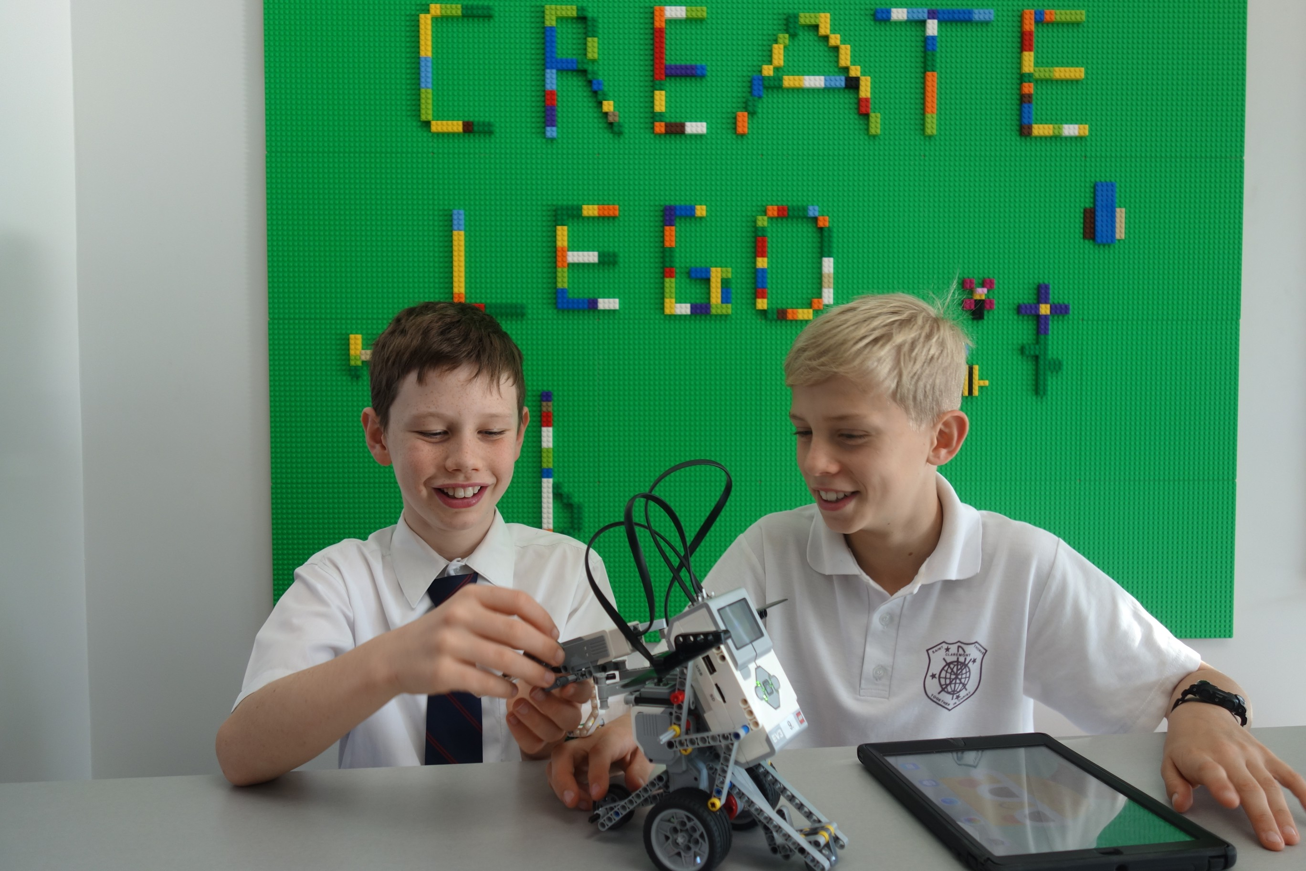
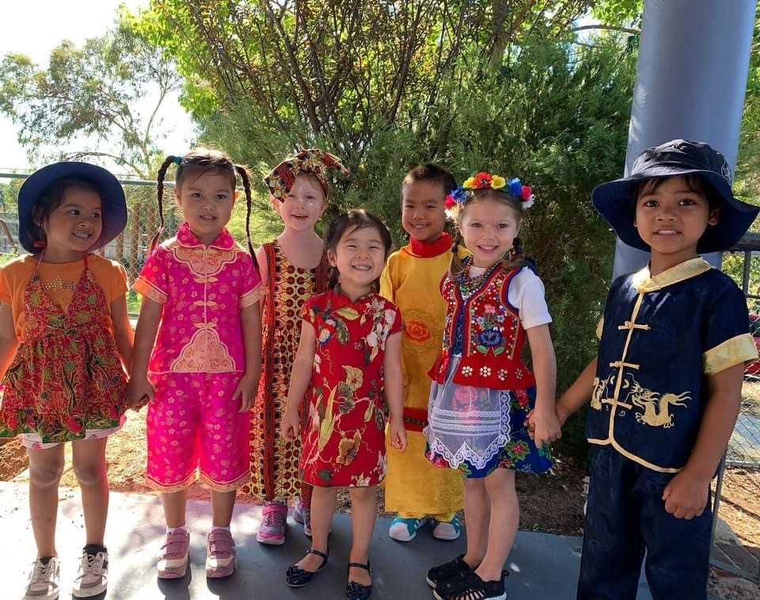

SCHOLARSHIPS
St Thomas’ Primary School is excited to offer families in our Parish community, an opportunity to enrol their children at our school through a Scholarship Program. This program will provide substantial financial benefit to support families who desire a Catholic Education for their children.
These scholarships are open for all year levels, Kindergarten through to Year 6. Scholarships will be offered for the start of Term 1, 2023.
CRITERIA
- Applicants must be Catholic
- Applicants must be supportive members of St Thomas’ School Community and be prepared to abide by the school ethos and policies.

The scholarship will cover tuition fees and other fees at the discretion of the Principal.
Costs not covered by the Scholarship include booklist, uniform, external music tuition, student iPads (for Years 3-6 students), excursions/camps, swimming lessons.

If successful in your application, the scholarship will be available for your child throughout their school years at St Thomas’ Primary School. We welcome applications from children who reflect our values and who are eager to fully participate in the school’s life and all the opportunities St Thomas’ Primary has to offer.

To ensure continuation of the scholarship benefit, families must adhere to the Code of Conduct and school policies and be contributing member of our school community. Retention of a Scholarship is conditional upon the holder maintaining academic endeavour and high standards of conduct throughout their schooling at St Thomas’ Primary.
APPLICATION FOR ADMISSION CHECKLIST:
To apply for this Scholarship at St Thomas’ School, please ensure that you have completed all sections of the application and have attached copies of the documents requested below.
- Application Form for St Thomas’ School Scholarship
- Copy of current Immunisation History Record (available via Medicare)
- Parish Priest Reference
- Certified copy of Full Birth Certificate and Visa Information (if applicable)
- Copy of Baptismal Certificate
- Copy of previous school reports (if applicable)

PROCESS
- St Thomas’ School will confirm in writing receipt of your completed application.
- An interview with the Principal of St Thomas’ School will be arranged for Parents/Guardians and the student for shortlisted applicants.
- Scholarships are awarded at the discretion of the Principal.

Applications must be received by 4pm on Tuesday 15 November 2022.
Please note: All scholarship applications will be treated with the utmost confidentiality.

If you are applying for a scholarship for more than one child in your family, please complete a separate form for each child.
CONTACT INFORMATION:

Attn: The Principal
Mail: St Thomas’ Primary School,
8 Warden Street, Claremont WA 6010
Phone: 08 9286 9500
Email: admin@stthomas.wa.edu.au
Website: https://www.stthomas.wa.edu.au/

STUDENT DETAILS:

Surname:
Given Names:
Known as:
Date of Birth: | Gender: Male Female
Student’s Residential Address:
To Commence Year Level:
Current School: | Current Academic Year:
Previous Schools Attended and Years:

SIBLING DETAILS (please place in order of birth):

Name: | Date of Birth:
Name: | Date of Birth:
Name: | Date of Birth:
Name: | Date of Birth:

MOTHER/GUARDIAN DETAILS:

Surname: | First Name:
Address:
Mobile No: | Home No:
Work No: | Email:

FATHER/GUARDIAN DETAILS:

Surname: | First Name:
Address:
Mobile No: | Home No:
Work No: | Email:

Please tell us why you would like to apply for a Scholarship to attend St Thomas’ Primary School:

Please indicate any financial or other family circumstances deemed relevant:

Do you have any Government concession cards?
Yes Details:
No

Please describe for us your involvement in the current school community:

How can you contribute to our school community?

By signing this form, I/we understand that all details supplied in this form will be held in the strictest confidence by the Principal and the Parish Priest. The information contained in this application is true in every particular. All Scholarships are awarded on the basis that our child will maintain high standards of academic endeavour and conduct throughout their enrolment and remain at St Thomas’ Primary until the conclusion of Year 6.

Name of Parents/Guardians: /

Signatures: / Date:

Our Vision is to 'educate the whole child' and empower learners as global citizens, to be curious, collaborative, creative and critical thinkers, inspired by Christ.

